Operant Conditioning Practice Name _____________

- Identify the behavior and its consequence.
- As a consequence of the behavior, is something added or removed/avoided?
- Does the consequence strengthen or weaken the behavior?
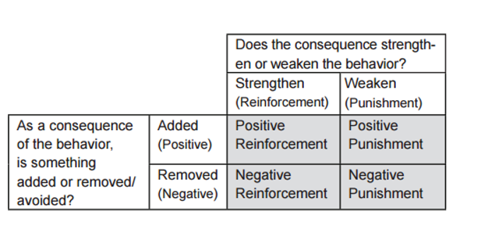
For each situation, fill out the chart, and then name the type of conditioning

- The police stop drivers and give awards for safe driving. This is _________________
Behavior |  | Consequence:
Added (or) |  | Subtracted
Strengthened (or) |  | Weakened

- The coach removes a player for the game for committing a foul. This is _______________
Behavior |  | Consequence:
Added (or) |  | Subtracted
Strengthened (or) |  | Weakened

- Player makes an error and the teammate calls him a bad name. This is _______________
Behavior |  | Consequence:
Added (or) |  | Subtracted
Strengthened (or) |  | Weakened
- A suspect confesses to a crime which ends the interrogation. This is _________________
Behavior |  | Consequence:
Added (or) |  | Subtracted
Strengthened (or) |  | Weakened

- Child cleans the room and parent stops nagging. This is _________________
Behavior |  | Consequence:
Added (or) |  | Subtracted
Strengthened (or) |  | Weakened

- Older brother sits on you until you say he's smarter, then he gets off. ___________
Behavior |  | Consequence:
Added (or) |  | Subtracted
Strengthened (or) |  | Weakened

- After completing your homework you get your cell phone back. _______________
Behavior |  | Consequence:
Added (or) |  | Subtracted
Strengthened (or) |  | Weakened

- When you buckle your seatbelt, the annoying beep stops in your car. ___________
Behavior |  | Consequence:
Added (or) |  | Subtracted
Strengthened (or) |  | Weakened

- Make up an example for other students to try: Write the question on the board and below, fill out the chart and give your answer.
Your example:
This is _________________
Behavior |  | Consequence:
Added (or) |  | Subtracted
Strengthened |  | Weakened

