**Components of a Neuron**

**Learning Target:** Identify key part of a neuron.

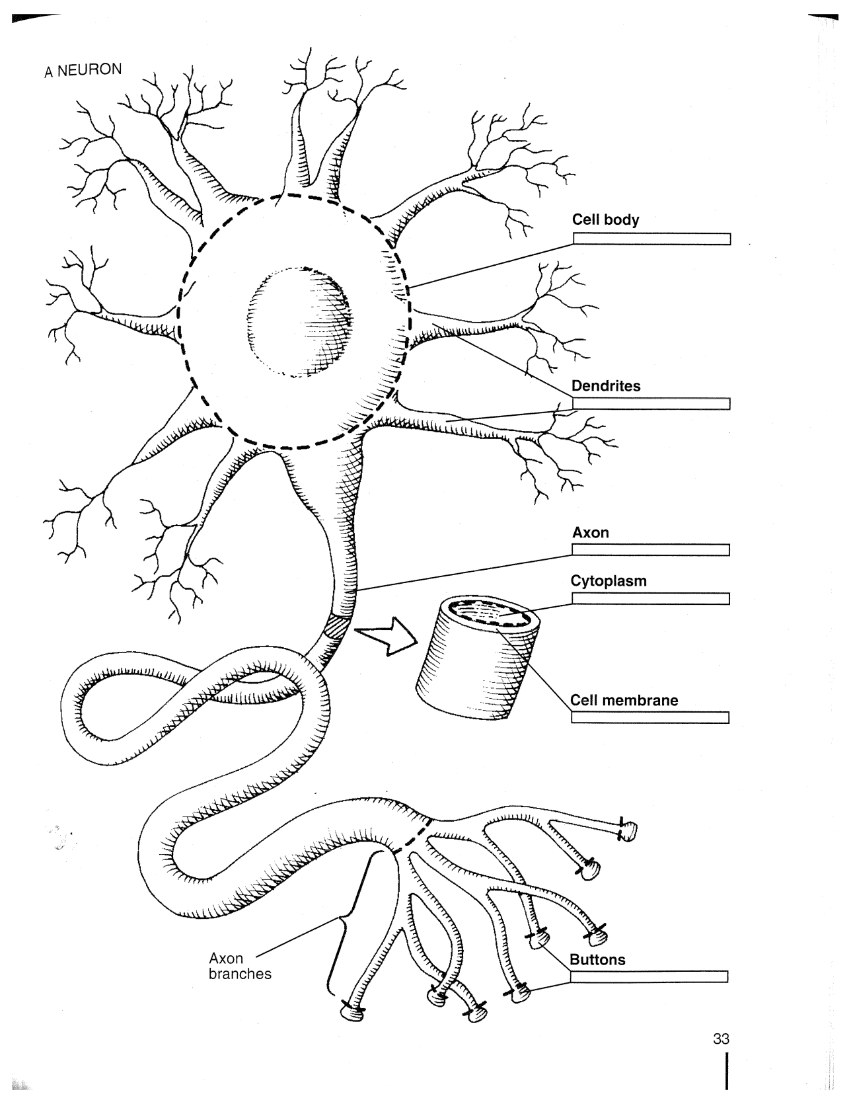

**Directions:** Label each of the following parts of the neuron and color them according to the instructions provided.

Axon Hillock – Red Axon – Orange Soma/Cell Body- Light Green

Axon Branches – Pink Nucleus – Brown Axon Terminal Buttons – Yellow

Dendrites – Light Blue Receptor Sites – Dark Green

Myelin – draw the myelin on the outside of the axon and label the Nodes of Ranvier

Synaptic Vesicles – Draw and enlargement on the side of a terminal button and show these structures

**Illustration:** Pinel, John P. J., and Maggie Edwards. *A Colorful Introduction to the Anatomy of the Human Brain: A Brain and Psychology Coloring Book*. Boston, Mass: Allyn and Bacon, 2008. Print.